**SQL Assignment 1**

**Northwind database products table**

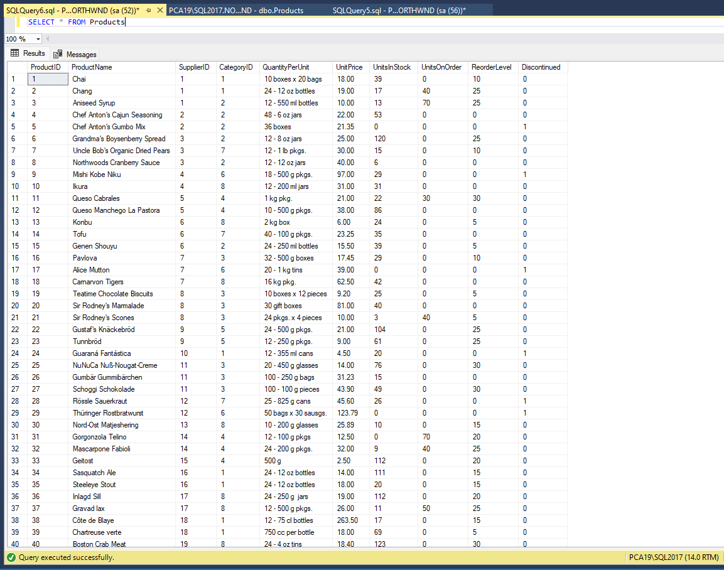

**Query 1 : Write a query to get a Product list (id, name, unit price) where current products cost less than $20.**

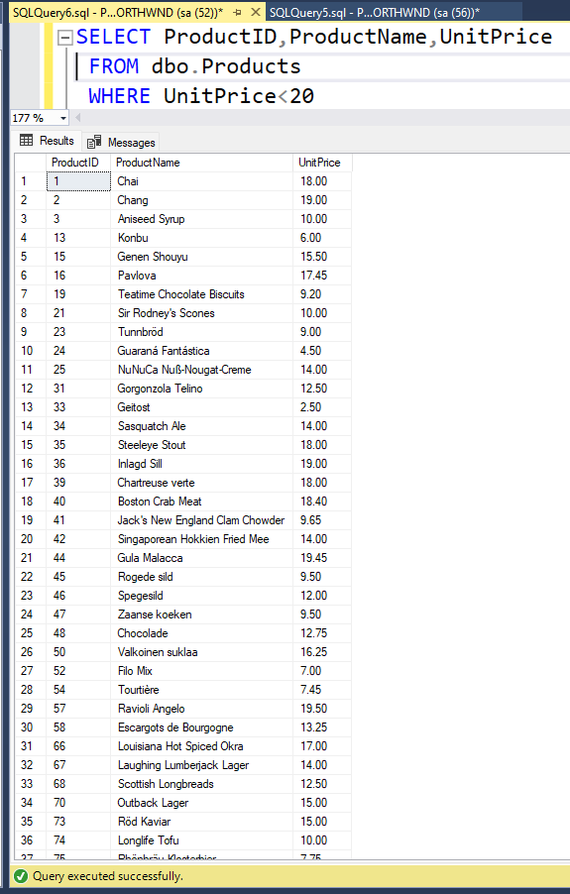

**Query 2: Write a query to get Product list (id, name, unit price) where products cost between**

**$15 and $25**

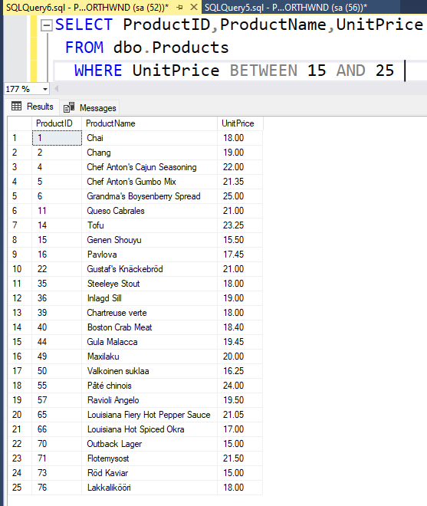

**Query 3 : Write a query to get Product list (name, unit price) of above average price.**

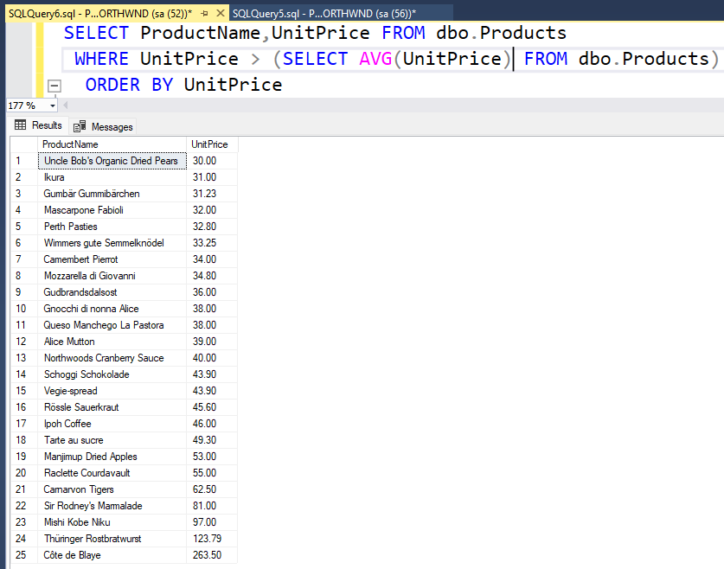

**Query 4: Write a query to get Product list (name, unit price) of ten most expensive products**

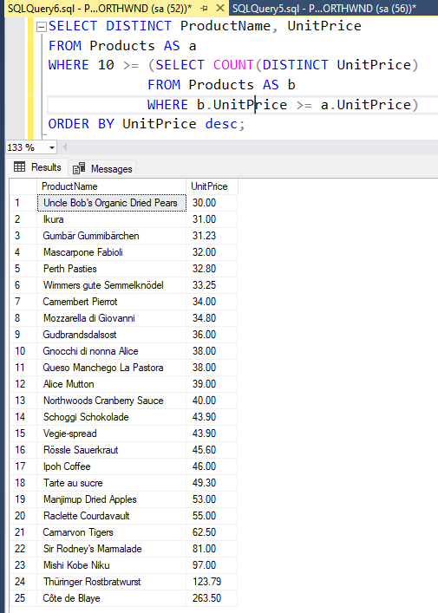

**Query 5: Write a query to count current and discontinued products**

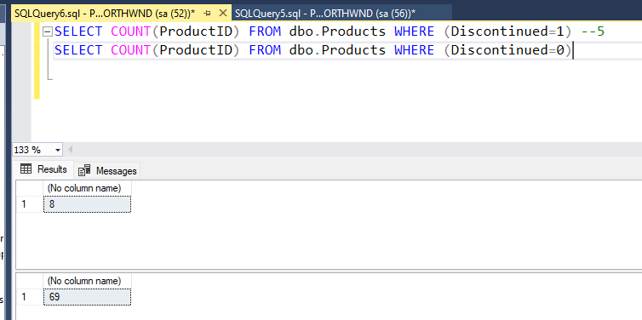

**Query 6 :Write a query to get Product list (name, units on order , units in stock) of stock is less than the quantity on order.**

